**Project Title: Global Suicides Analysis**

1. **File Structure:**
2. **Step-by-Step Manual**

**Move Files**

Please keep data file master.xlsx, master.csv, shiny_v1.0. R and Base_Analysis.R at the same working directory

**Installing**

Please take note below packages are required to be installed before running Shiny App, if not please run below commands:

install.packages(shiny)

install.packages(shinydashboard)

install.packages(ggplot2)

install.packages(dplyr)

install.packages(tidyverse) # general

install.packages(ggalt) # dumbbell plots

install.packages(countrycode) # continent

install.packages(rworldmap) # quick country-level heat maps

install.packages(gridExtra) # plots

install.packages(broom) # significant trends within countries

install.packages(readxl)

install.packages(DT)

install.packages(highcharter)

install.packages(viridis)

**Testing**

After installation completes, please run app shiny_v1.0.R

Test 1: If below screening comes out, verification 1 success.

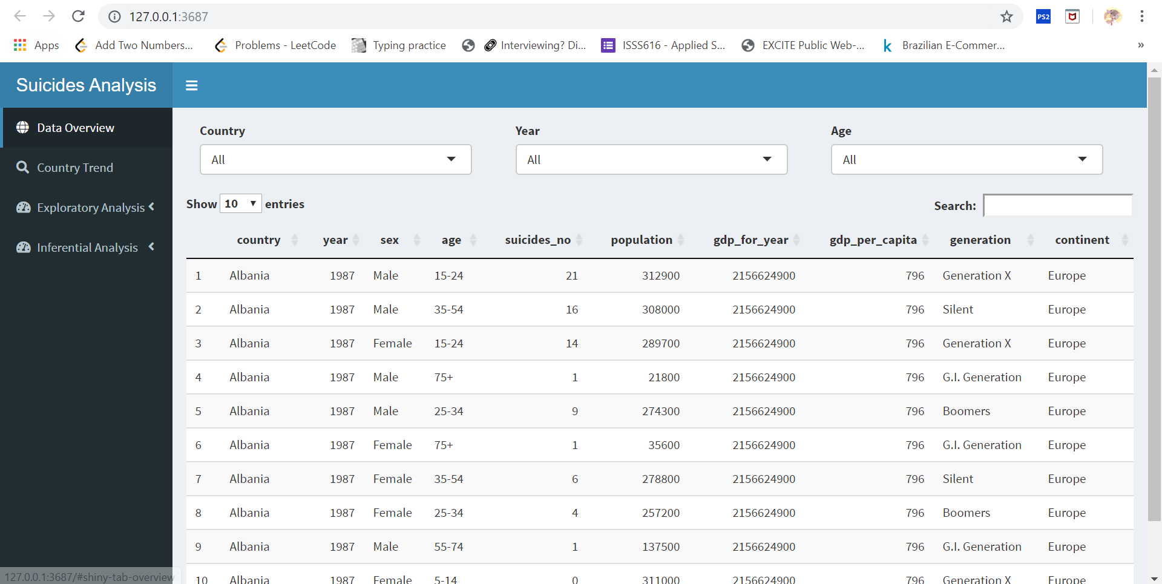

Test 2: Click menu Exploratory Analysis – Continent, If below screening comes out, verification 2 success.

